***Linux Commands***

**ls Command:**

* This command is used to lists the files and directories in the current directory

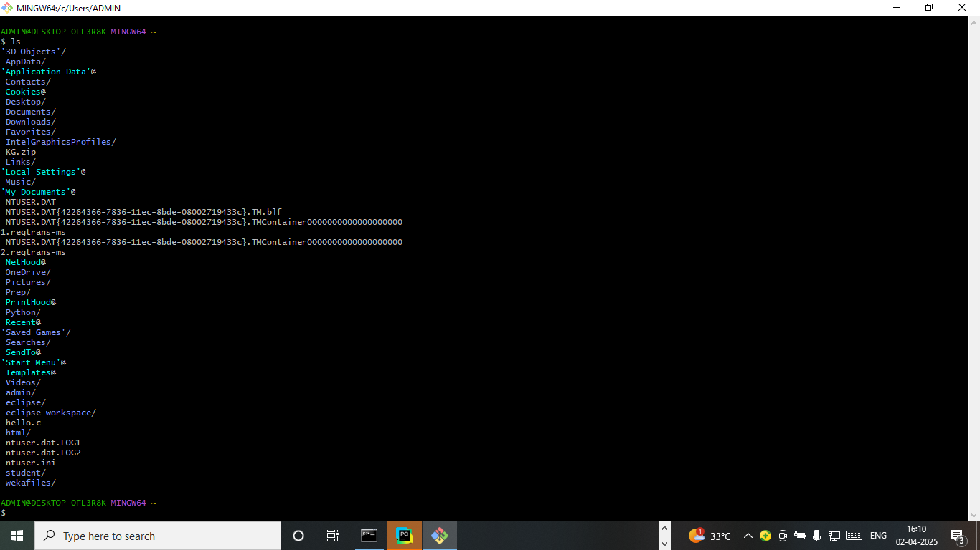

**cd command:**

* cd command is used to change the directory

**mkdir command:**

* mkdir is used to create the directory

**rmdir command:**

* This command is used to remove the directory

**cp command:**

* Cp command is used to copy the information from one file to another file

**pwd command:**

* pwd command shows the current working directory

**rm command**

* This command is used to delete the files that are in current directory

**mv command:**

* This command is used to change the name of the file

**uname command:**

* This command gives complete information about operating system

**touch command:**

* This command create new file in the current directory

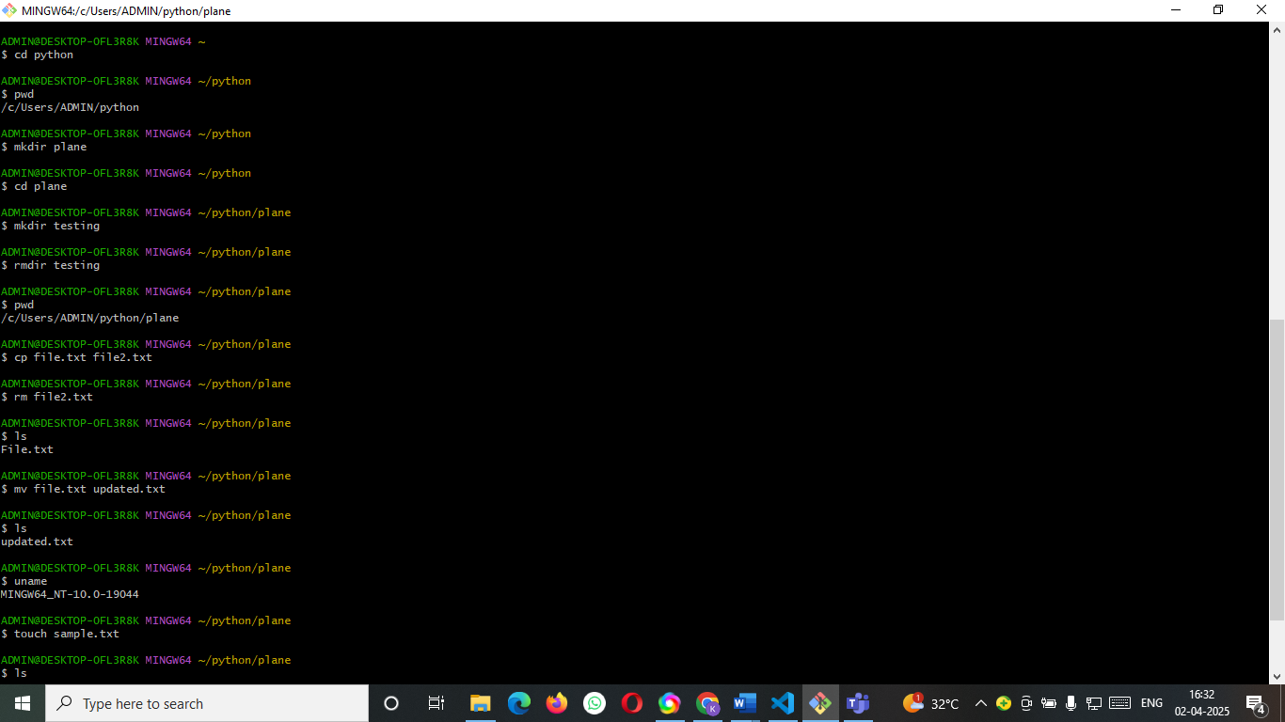

**Cat command:**

* This command is used to print information in the file

echo command:

* This command is used to print the information that are written in the git bash

**grep command:**

* Grep command is used to find specific string in series of outputs

**sort command:**

* This command used to sort the output file

**df command:**

* This command gives the complete information about the file System

**df-h command:**

* This command is similar to df command but it will return the output in bytes

**clear command:**

* This command is used to clear the terminal

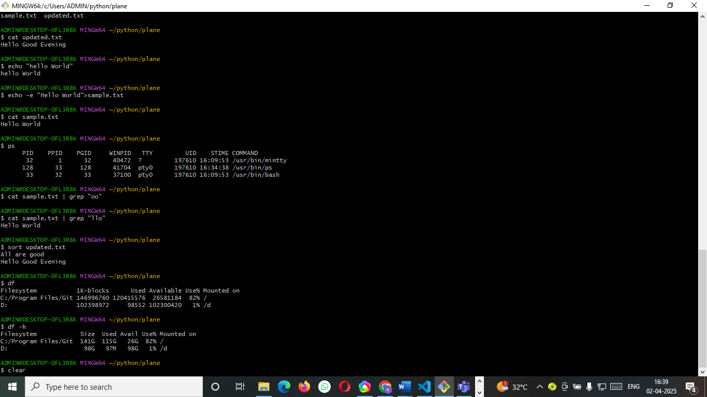

**wc commands:**

* wc -w command is used to return the number of words that present in the file
* wc -l command is used to return the number of lines that present in the file
* wc -m command is used to return the number of characters that present in the file

